# Tutorial 3

## Name: Zhaokun Su

## Breakout group: 4

## Zid: z5235878

**(i) The Sussman anomaly, shown below, is a simple planning problem that could not be solved by the early linear planners. Show how a partial order planner would solve this problem with blocks world operators defined above.**



Tutorial notes about question 3:

start state: clear (B), clear (C) and on (C, A);

goal state: on (A, B), on (B, C) and clear (A).

discuss (a): why linear planning cannot solve Sussman anomaly problem?

We know that for linear planner, it solves problem mission by mission. In other word, it our missions are separate with each other, this problem can be solved by linear planner because the achievement of one separated mission has no effect to another mission as missions are independent with each other. For our specific question: in order to achieve goal state, we need to handle with 3 tasks, they are:

1. on (A, B)
2. on (B, C)
3. clear (A)

And they are not independent each other although it seems like these tasks could be done with different orders.

discuss (b): why Sussman anomaly problem can be solved by non-linear planner?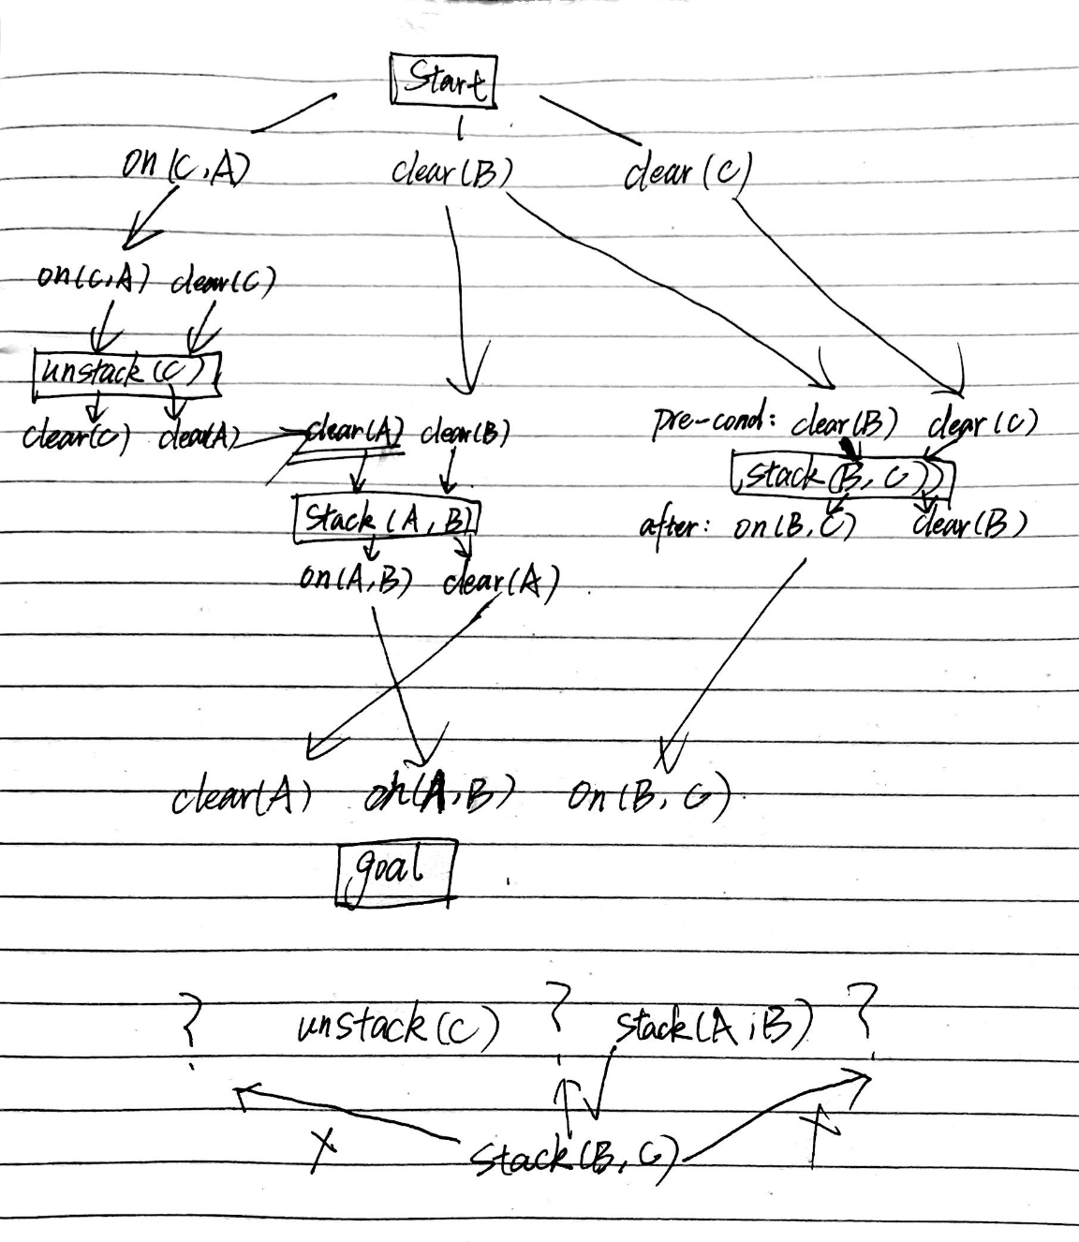

Looking at goal states: on (A, B), on (B, C) and clear (A) and analysing from the figure below, it is necessary to derive Stack (A, B), Stack (B, C) and Unstack (C) in order to get clear (A), on (A, B), on (B, C).

And the next step is to determine the order of above three operations.

We know that clear (A) as a pre-condition of Stack (A, B), so action Unstack (C) should be acted before Stack (A, B), and then we know that stack(B, C) cannot be before Unstack (C) due to violating pre-condition clear(c) of unstack(C). And the same reason for Stack(B,C) after stack(A, B), so the correct order is :

1.unstack (C) 🡪 2.stack (B, C) 🡪 3.stack(A, B)